2nd Internal Examination

Turbomachines

Institute of Engineering, Pulchowk Campus, Lalitpur

Full Marks: 15 Time: 45 mins

Pass Marks: 6

Attempt All Questions

1. Define propulsive efficiency, by-pass ratio, specific impulse and installed thrust. With reasons, compare turbojet and turbofan engines in respect to their total efficiency. [2 + 2]
2. Figure 1 below shows a velocity diagram of a turbine stage. Assume following data: Angle between C2 and C3 to the axial direction are 50º and 20º respectively. Also, the magnitude of C2 and C3 are 400m/s and 300m/s respectively. Find the total enthalpy changed by the rotor blade row. Also assume rotational speed u = 200m/s. [4]

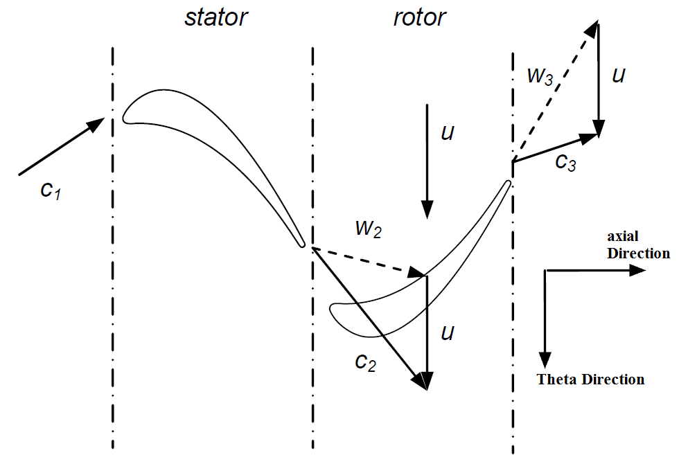

Figure 1: Turbine Stage

1. Explain the difference between polytropic and isentropic process. Also, draw simplest polytropic expansion process for 3 stages of turbine blade row using h-s diagram. [2+2]
2. Explain various lines in a compressor performance chart using a schematic diagram. [3]

\*\*\*\*\* Best of Luck \*\*\*\*\*